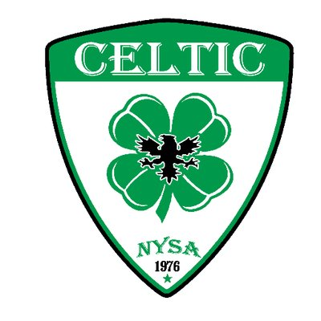 | NORMAN YOUTH SOCCER ASSOCIATION  BOARD OF DIRECTORS & COMMITTEE MEMBER APPLICATION

Thank you for your interest in joining the Norman Youth Soccer Association (NYSA) Board of Directors and/or its committees. Please complete the following form and submit to BoardOfDirectors@OklahomaCeltic.com and/or mail a copy to the attention of the NYSA Board of Directors at 1001 East Robinson Street, Norman, OK 73071. The information you provide as part of this application may be reviewed by the current Board of Directors, as well as one or more of its committees, for the purpose of identifying and evaluating potential board and/or committee candidates. Please note that according to Article VI, Section 11 of the Bylaws of Norman Youth Soccer Association, “No one being paid by NYSA shall be eligible to serve as a member of the Board of Directors.” and, “A person shall not be eligible to serve as a member of the Board of Directors if related by blood or marriage to a person serving as a member of the Board of Directors.”

CANDIDATE INFORMATION

Full Name: | Input Last Name | Input First Name |  | Input Middle Initial
 | Last | First |  | M.I.
Address: | Input Street Address |  | Input #
 | Street Address |  | Apartment/Unit #

Input City | Input State | Input Zip Code
City | State | Zip Code

Phone #: | Input Phone Number | Email: | Input Email Address

Present Occupation: | Input Present Occupation or Job Title
Place of Employment: | Input Current Place of Employment

Please provide your educational background, including your highest level of education and area of study, as well as any certification, training or professional licenses which you may possess.
Input Answer

CANDIDATE QUESTIONNAIRE

Please indicate your areas of expertise by checking all of the following that apply:

☐ Accounting ☐ Facility and/or Field Management ☐ Policy Development
☐ Administration ☐ Finance ☐ Public Relations
☐ Advocacy ☐ Fundraising ☐ Soccer
☐ Board Development ☐ Grant Writing ☐ Strategic Planning
☐ Communications ☐ Human Resources and Staffing ☐ Volunteer Coordination
☐ Community Service ☐ Law ☐ Other (Describe Below)
Input Other Expertise
☐ Community Outreach ☐ Management and/or Leadership
☐ Event Planning ☐ Nonprofit Experience

If selected to serve on the Board of Directors or its committees, in which position(s) or committee(s) do you believe you would make the greatest contribution to NYSA? Why?
☐ President ☐ Sportsmanship and Rules Committee
☐ Secretary ☐ Scheduling Committee
☐ Treasurer ☐ Bylaws and Appeals Committee
☐ Recreational Representative ☐ Coaches Committee
☐ Competitive Representative ☐ Finance Committee
☐ Marketing Representative ☐ Ways and Means Committee
☐ Member At-Large ☐ Nominating Committee
☐ Fields Committee
☐ Complex Committee

Input Answer

Please list any and all nonprofit boards and committees on which you currently serve, or have served in the past, and include the name of the organization, your role or title and your years of service.
Input Answer
Approximately how much time will you be able to devote weekly to serving the mission and fulfilling the vision of NYSA as a member of its Board of Directors or committees?
Input Answer

Please describe your involvement, past and present, with NYSA (e.g. any current or former youth player(s) registered with NYSA, volunteer or staff coach, Team Manager or other leadership, former NYSA player, etc.).
Input Answer

How many years have you, or your children, been a member of NYSA?
Input Answer

Please describe your involvement in soccer, and/or other youth sports, outside of NYSA.
Input Answer

Why are you interested in serving on the NYSA Board of Directors and/or its committees?
Input Answer

What do you hope to gain from your experience serving on the NYSA Board of Directors and/or its committees?
Input Answer

What do you believe is the most pressing issue or problem presently facing NYSA? Why?
Input Answer

Please provide a brief description of your characterization of a successful youth soccer organization.
Input Answer

Have you reviewed and familiarized yourself with the NYSA Bylaws, Mission and Vision Statements, Core Values and the programs offered by the organization?
YES ☐ NO ☐

Are there any personal or professional conflicts of interest, current or anticipated, of which the NYSA Board of Directors and/or its committees should be aware of as part of considering this application? If yes, explain.
Input Answer

Are you presently compensated, or do you anticipate being compensated during your term on the Board of Directors or its committees, by NYSA in any way, including payment in kind? If yes, please explain.
Input Answer

Are you related by blood or marriage to a person presently serving as a member of the Board of Directors? If so, who?
Input Answer

If you are not selected as a member of the Board of Directors or the committee to which you are applying, would you be willing to volunteer your time to assist the organization by serving on a committee in lieu of the board or a committee other than the one for which you are applying?
YES ☐ NO ☐ MAYBE ☐

CERTIFICATION and Signature

By submitting this application, I hereby certify the information provided is true and accurate to the best of my knowledge. Furthermore, I understand false or misleading information contained herein may result in my release, should this application lead to an appointment on the Board of Directors or its committees.

Signature: | Input Electronic Signature | Date: | Input Date

